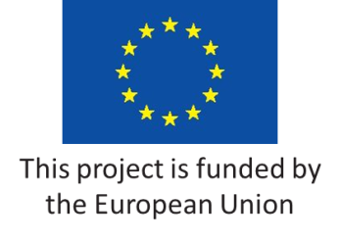 | EU for Public Administration Reform (EU4PAR)  Bosnia and Herzegovina | 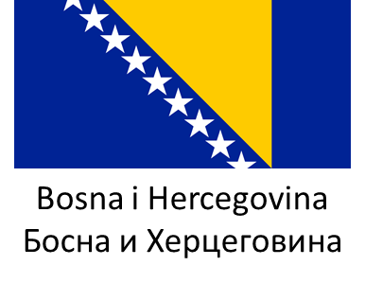

Agenda

Title |  | Thematic discussions within the Supervisory teams on priorities and revision of the activities of the SOPAR Action Plan
Target group |  | Five supervisory teams:  - Policy Development & Coordination  - Public Service & Human Resources Management  - Accountability  - Service Delivery – Better service delivery & Quality  - Service Delivery – Digitalization
Subject matter |  | Discussion on the proposal for revision of the SOPAR Action Plan by reform areas separately
Date and time |  | 15-16 May 2024
Place |  | Hotel Hollywood, Ilidža – Sarajevo, Dr.Mustafe Pintola 23
Background
Pursuant to the agreed timeline for prioritization and revision of SOPAR Action Plan, the PARCO and EU4PAR are to organize several cycles of consultations and deliberations to revise the SOPAR Action Plan. This particular event will be dedicated to the discussion on the results of the Prioritization exercise devised by the SIGMA and executed by the PARCO and EU4PAR team. The discourse is going to be carried out by reforms area separately. The expected outcome of the event will enable the formulation of the first draft of the Revised Action Plan.
May 14th 2024
At will | Arrival of the participants from RS and BD
19:00 | Dinner for the participants accommodated at the hotel
May 15th 2024
 | Breakfast for the participants accommodated at the hotel
09:30-10:00 | Registration of the participants
10:00-10:30 | Welcome address by the PAR Coordinators and EU4PAR TL in a plenary session
10:40-12:30 | First round of consultations – separate sessions of the supervisory teams
12:30-13:00 | Coffee break
13:00-15:00 | Second round of consultations – separate sessions of the supervisory teams
15:00 | Lunch break for all participants
19:00 | Dinner for the participants accommodated at the hotel
May 16th 2024
 | Breakfast for the participants accommodated at the hotel
09:30-11:30 | Third round of the consultations - separate sessions of the supervisory teams
11:30-12:00 | Coffee break
12:00-13:30 | Wrap up and closing address in a plenary session
13:30 | Lunch break for all participants and check out

